Getting Started with HTML & CSS

1.1: Getting Started with Your Frontend Course

Learning Goals

* Configure your developer environment
* Explain the difference between front and backend development
* Compile portfolio research into an inspiration board

 Estimated Read Time: 1 Hour.

Introduction

Welcome to Frontend Development for Designers! We feel privileged to have you here and hope you’ve had a positive experience with CareerFoundry thus far.

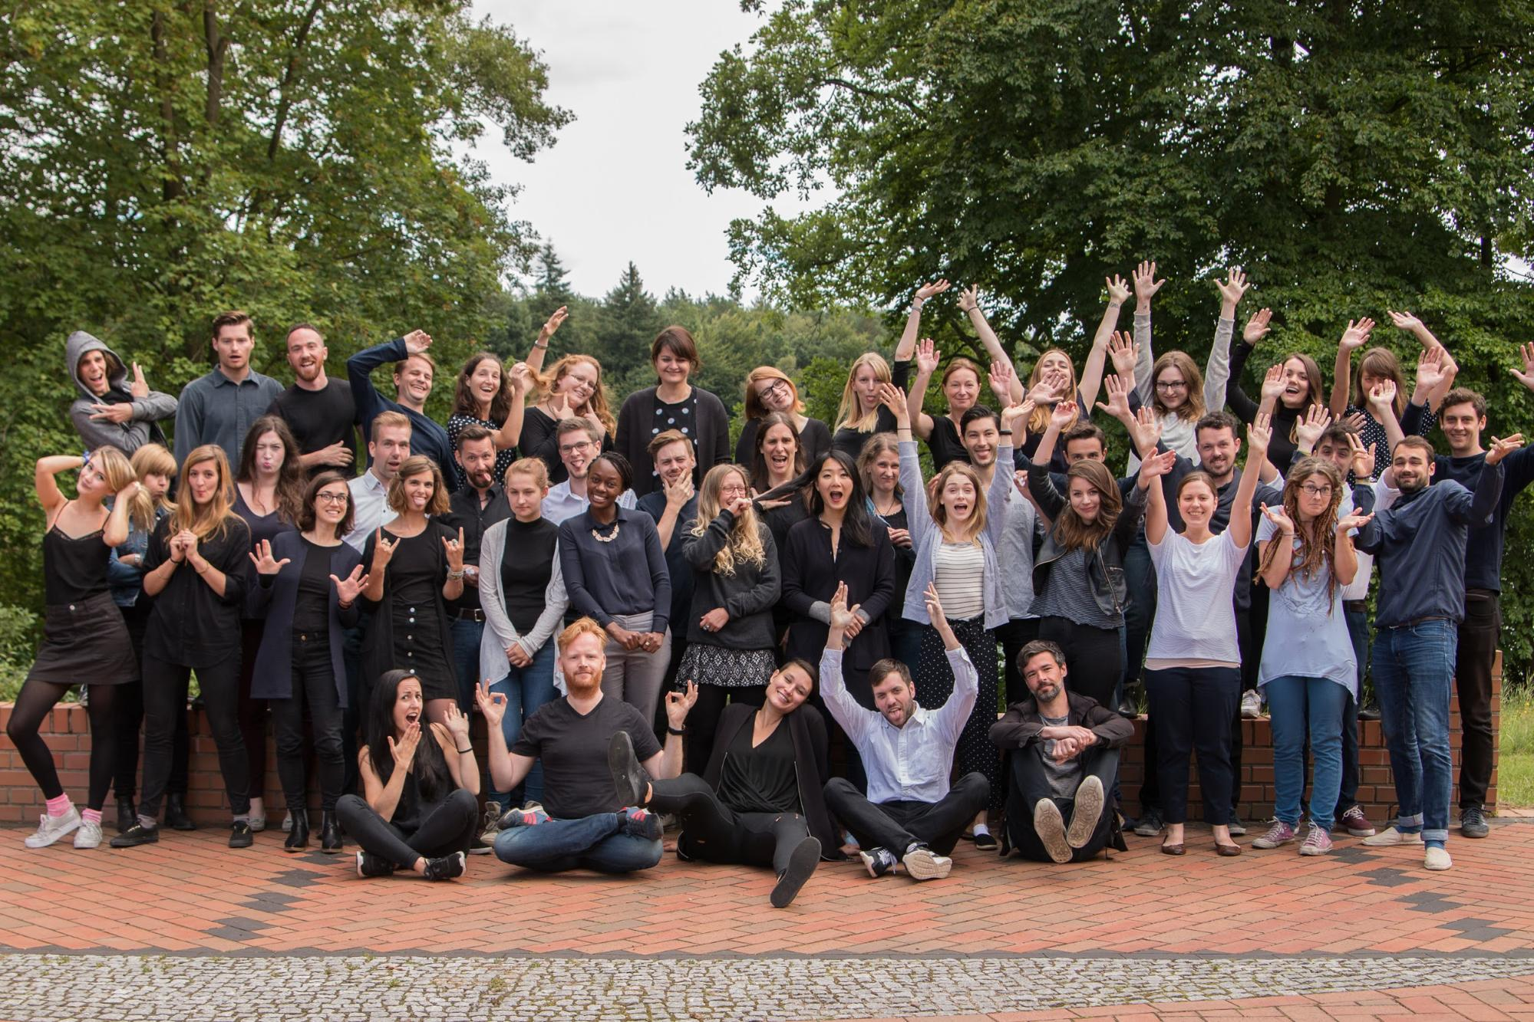

Understanding the foundations of programming is an important part of any design professional’s skillset. This is especially true for designers who regularly collaborate with developers. In this course, you’ll gain valuable insights into how to work with design considerations alongside technical requirements. You’ll also learn how to build your own functional website following best practices in writing frontend code!

As mentioned in the [Course Prep](https://careerfoundry.com/en/course/61/course_prep#2), you’ll begin this course by revisiting your previous design work and selecting specific projects to be featured on your portfolio site. Therefore, this first Exercise will focus on identifying user goals for your portfolio site, curating a list of work to be featured on your website, and preparing the copy to accompany your design work.

As design is iterative by nature, you might find yourself wanting to feature a different set of design work or revising your user goals as you progress through the course. This is perfectly fine! Whether or not you end up changing your mind, it’s important that you start with a solid body of work for a better sense of how to design your portfolio site.

There might be a few learning curves ahead, but you can always count on your Mentor and the CF team for ongoing support. Last but not least—we hope you have a blast!

Meet the Course Writers

This course was written by two talented professionals in programming and design, both of whom worked tirelessly to make this course a reality. Take a few moments to read their bios below!

Lisa Gringl

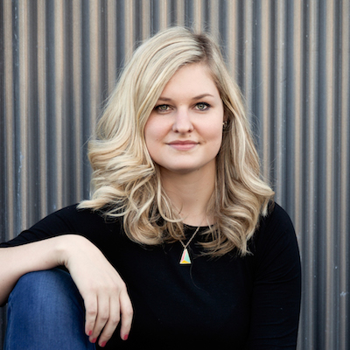

**Where are you based?**  
I am currently living in Austria in the lovely town of Innsbruck.

**How do you spend your free time?**  
I travel a lot. I love to discover new places around the world. When I’m not travelling, I love to spend time with my family in Vienna and Carinthia. I’m also obsessed with games. I love every type of game—card games, board games, video games—but my most favourite game by far is Settlers of Catan. On Sundays, I can spend hours playing it, one round after another.

**What’s a fun fact about you?**  
I’m a very organised person when it comes to my work life—I have everything well-organized and planned. When it comes to my private life, though, I’m one of the most chaotic people you’ll ever meet. I swear, I lose my smartphone five times a day!

**What’s your professional experience?**  
I actually started university in St. Pölten to become a developer. I had basic knowledge of some programming languages, and I thought it would be my dream profession. During university, we often had to work in teams to get a project done, which meant someone needed to take on the designer role. However, no one actually wanted to do it, so I did it, and thus slipped into becoming the UI designer for every group project. Over time, I got better and better at it. By the time I started my master’s degree on digital media technology, I already knew that I wanted to focus more on user experience design and that I wanted to share the knowledge I’d gathered thus far with others.

I started to teach some courses at university and held some talks at conferences. Meanwhile, I worked as a freelancer on different design projects. After I finished my studies, I started at Cropster, a company that provides software for the specialty coffee business, from farmers to roasters. I started by building a new product (Cropster Hub) along with the design language behind it. Then, I established Corporate Design Guidelines and started to build a design system for all Cropster products.

Now, I’m the Head of User Interface Design at Cropster, where I conduct user research, create concepts for new features, and work closely with our development team to implement them. I love my job, because there’s a new challenge every day for my team, that we tackle together, supported by an extraordinary cup of coffee.

**Why do you think having frontend skills is valuable for a designer?**  
If you understand the possibilities and limitations of the systems you’re working with, you can produce a much better design. Believe me—once you’ve learned the basics of CSS, HTML, and JavaScript, you’ll design user interface elements differently. You’ll look at your designs and think about how they can be translated into CSS. You’ll see two different styles for headings on the same hierarchy, and you’ll naturally unify them. You’ll design with more consistency in mind. In addition to that, you’ll be able to communicate your designs to the development team more efficiently—in fact, the designer should be part of the development team. Your design can only be as good as its implementation. The closer the designer works with the developer, the better.

Francesco Novy



**Where are you based?**  
I grew up in the beautiful city of Vienna, Austria. After a brief time in Sacramento, California, I now live in the lovely city of Innsbruck, located between the mountains of the Austrian alps.

**How do you spend your free time?**  
When I’m not working on websites, I love to travel the world. When I’m not travelling, I love to read or play a nice, competitive round of Mario Kart. Thanks to my work, I also grew a passion for specialty coffee—which has led to me searching out nice cafes wherever I end up.

**What’s a fun fact about you?**  
One of my favorite parts about travelling is simply walking through a foreign city for the first time. Experiencing what makes a city special is always a great treat, and I could walk around like this for hours on end. However, I absolutely hate going uphill—for whatever reason, I just can’t find any satisfaction in it. This can be especially difficult considering I live surrounded by high mountains, which other people might die to ascend. For me, though, they offer nothing more than (very!) pretty scenery.

**What’s your professional experience?**  
I studied at the University of Applied Sciences in St. Pölten. Initially, my focus was on writing HTML, CSS, and JavaScript. However, during my studies, I also learned about many UX-related topics. I ended up working for a web design agency, where I built websites for small- to medium-sized clients.

After I finished my master’s degree, I started work at Cropster, a company based in both Innsbruck and Sacramento. I was hired to lead the work on migrating a huge, existing, web-based application to newer, more competitive technology. This included re-writing many years of old HTML and CSS code into a more modern, standards-compliant codebase using state-of-the-art HTML, CSS, and JavaScript technologies.

In addition to being the lead frontend developer on the team, I also act as technical product manager. This means that I’m responsible for coordinating some of our products between the designers, developers, and sales staff.

In addition to all this, I once held a course on web development at university and gave some talks and workshops on topics ranging from collaboration between designers and developers to data visualization.

**Why do you think having frontend skills is valuable for a designer?**  
I think there are two key benefits in designers knowing about HTML, CSS, and JavaScript. First of all, it allows designers to better understand the constraints of the designs they’re creating. Once you know what CSS can and can’t do, for example, it’s much easier to create designs accordingly. The second key benefit is this: It improves communication between designers and developers. If these two often-opposing groups have a decent understand of what the “other side” does, it’s much easier to avoid frustrating issues with collaboration.

How Your Course Works

Your course is divided into two main Achievements, which, together, contain a total of 14 hands-on Exercises for the entire course. The Exercises are lessons focused on a specific aspect of a coding language, and each Exercise ends with a Task in which you can immediately apply what you’ve learned to a deliverable related to your course project.

In this course, we’ll cover the basics of **frontend development**, which involves working with **descriptive** (HTML and CSS) and **programming** (JavaScript) languages to produce a website that users can interact with directly. This course will ensure you acquire a solid understanding of how the internet works and how websites are built with frontend languages (with an emphasis on site accessibility and performance). While frontend development also encompasses the practice of building web applications, the course content will center around the development of a responsive website. Rather than working with pre-established frameworks (which generally come with a lot of unused code that can potentially slow down your site), you’ll get to experiment with advanced CSS styling and responsive CSS (among others) to see, firsthand, what it’s like to build something from the ground up. This will enable you to communicate technical requirements and work around design limitations effectively in your career. Plus, it’s fun and memorable to build something from scratch!

TIP!  
If you stumble upon terms you’re not familiar with, do a quick Google search for an explanation. There are a lot of great examples out there that effectively demonstrate specific development concepts; therefore, never hesitate to do outside research! If some of the concepts are still giving you a hard time even after your research, mark them to discuss with your Mentor.

You’ll be using the website you build to host your design work, building (in essence) your very own responsive portfolio site. Alternatively, you could include this website as a portfolio piece in your existing portfolio to show off your technical understanding and frontend programming skills.

Your Course Project

Throughout this course, you’ll be working on a frontend web development project that involves writing clean and functional code for your portfolio site. It’s important to keep in mind that, while the tools you’ll be using are free and open source, you’ll be responsible for purchasing a domain of your choice and paying a small annual fee for web hosting services if you decide to actually launch your website on the web. If you don’t want to pay for a service, however, you can simply share your code and the project itself on GitHub—a tool we’ll discuss in greater detail toward the end of the first Achievement.

For now, let’s take a look at the project brief and go over some prep work that will help set your project up for success!

[**Frontend Development for Designers Project Brief: Your Portfolio Site**](https://images.careerfoundry.com/public/courses/frontend/New%20Update/Project%20Brief%20Wireframes/Frontend%20Project%20Brief%20New.pdf)

The project brief comes with foundational information such as the objective, the context, the 5 W's (Who, What, When, Where, and Why), as well as general guidelines on what features and requirements your portfolio site should include.

As you work through the course, you’ll notice that nearly all of the Tasks at the end of the Exercises contribute to your project. There’s a tiny exception in Achievement 2, where you’ll step away from your project for a moment and focus on problem-solving with JavaScript. This is to ensure you’ve had enough practice and feel confident when it comes to coding the “real thing.” Don’t worry, though, because everything will come together in the very next Exercise.

You might have also noticed that a critical piece of information—user goals—is missing from the project brief. This is on purpose! Although the general guidelines in the brief provide some key requirements, they’re meant to inform the overall direction of your site while giving you plenty of creative freedom to decide on the look, style, and messaging of your portfolio site. You should start solidifying your user goals as early as possible as this will help you create and continuously personalize the look and feel of your site. We’ll talk a bit more about user goals in a moment.

The project brief also contains links to a set of clean-looking wireframes. They may look a bit boring to you now, but wireframes are usually fairly simple and created in grayscale. They also come in three versions: mobile, tablet, and desktop. Like any user-friendly site, we want your portfolio site to be responsive and change depending on the device on which it’s being displayed. You’re likely familiar with the term “mobile-first” if you took one of our design courses. You’ll be using this approach here, as well. Think of the wireframes (and the mockups for the challenge task) as more of a guide, allowing you to focus your time and efforts on writing readable and error-free code. Trust us—your colleagues from all walks of tech and design savviness will thank you for this.

With that in mind, we do encourage you to make the portfolio site your own. Feel free to employ your own unique color scheme, typography, and copy to showcase your design work. We also recommend that you take on the optional challenge tasks and experiment with different CSS stylings to add further personal flair to your site.

TIP!  
If you already have an idea for a project of your own, you can work on completing it alongside your course project. Talk to your Mentor about any ideas you may have.

Now, let’s take a closer look at your users and their goals!

Identifying User Goals

In the most straightforward of terms, a **user goal** involves anticipating and understanding what a user wants to accomplish by using your product. For this project, the ultimate user goal is for people to see your design work and learn a bit about you. Based on that goal, you’ll curate your design work for the site.

Having information that’s targeted specifically to your users can often help ensure you’re moving in the right direction when it comes to curating your work. With that in mind, let’s see if we can get a bit more specific about who your intended users might be, their goals, and—hence—the design work you’ll want to curate for them.

Who Are Your Users?

From the 5 W's section of the project brief, we already know that we’re building a portfolio website with HTML, CSS, and JavaScript (*what*).

The brief also covers a bit about the intended user—in this case, a potential employer or anyone who wants to learn more about your design work (*who*). We encourage you to build on this a bit more. For example, if it’s a potential employer, what type of employer and in what specific industry? Would it be a designer from a startup without a lot of structure or from a medium-size company with a fairly democratic hierarchy? Determining this may help you better choose the correct tone of voice for your website.

Then, think about the context in which the user will visit your site (*when*). Will they be visiting your site through social media channels or other professional sites? Or, will they visit after meeting you in person at a networking event or conference? If the latter were true, for instance, it might be good to think of a domain name that’s easy to spot and remember.

Now, let’s discuss the location and devices your users will most likely be using when looking at your site (*where*). Is a project manager from an app development company looking at your site from her office? If so, what screen sizes should you consider for your website? Or, perhaps your target audience is a small business owner who wants to scale up his family-owned bakery’s design efforts. What type of device might he be viewing your site on? Will you need optimized images so your site will load faster on a mobile device?

With all the information you have up to this point, see if you can put together a few sentences describing your intended users. Just make sure the descriptions address at least one type of user and cover the W’s mentioned above.

WRITE IT ALL DOWN!  
That was a lot of questions to ponder and answer, so be sure to take some detailed notes. You’ll need them to inform your starting situations and test scenarios in Achievement 2 of this course.

Selecting Your Design Work

We still have one more W to cover, and this one concerns both the user and you. Now that we have a better idea of your intended users, it’s time to anticipate the type of design work and relevant design skills your site visitors might expect to see when visiting your portfolio site. If they want to learn more about your professional skills and experience (*why*), what should you select to best showcase this?

Let’s start with the overall messaging and style you want your portfolio website to deliver. If you already have an online portfolio, you can certainly draw inspiration from there. Then, go through the following steps to prepare all the necessary content for your portfolio site.

* Write down what your potential users want to see; for example, a hiring manager might want to see your CV or resumé as a PDF along with general design work, whereas a design manager might want to see photos of a design-thinking workshop in which you were the facilitator.
  + Organize your answers; for this you might want to create a grid like the one below:

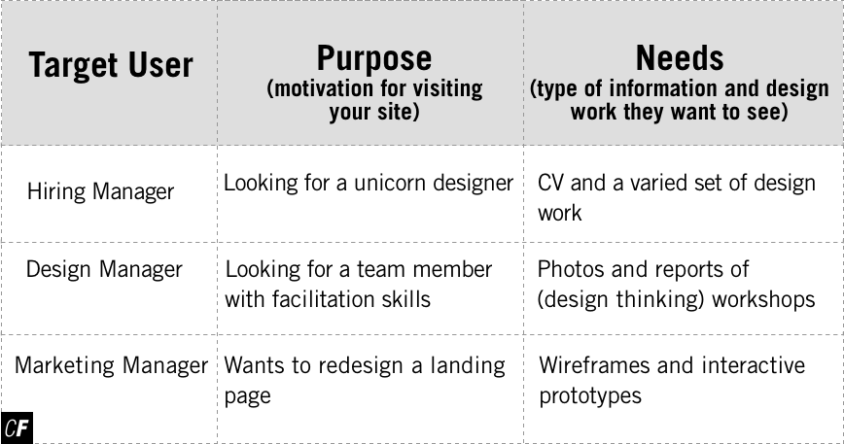

[Zoom in on table](https://s3.amazonaws.com/coach-courses-us/public/courses/frontend/1.0/frontendzerotable.png)

* Think about yourself. Your portfolio site will be a crucial element of your application package when applying for jobs. Besides showcasing your best work, it would also be a good idea to share information regarding who you are as a person and designer. Think about what makes you unique: your background, your strengths and weaknesses, your experience, your personal interests. This should, of course, be related to the role you’re after (a UX designer or UI designer, for example), but above all—be yourself. Sharing the skills and tools you’re proficient with would be a good addition, as well.
* Think about your work. Showcasing your work is a key aspect of your portfolio page. It’s what you’ll eventually be selected for, after all. But it’s not just about sharing images: it’s also essential that you explain the process behind your projects. Include an overview that describes, for example, the purpose, objective, role, and duration. Next, explain the overall process, including what stages you went through. Be thorough, but keep it concise. Images are also recommended, though make sure they’re relevant and of good quality. Don’t forget the conclusion and a (link to a) working prototype if you have it. You could also decide to write a case study.

Let’s take a moment to talk a bit more about images. They come in a variety of formats, making it crucial to understand their differences and use the correct sizes in your portfolio site.

* **JPG** (pronounced “jay-peg”): This is the default format for images such as screenshots and photographs. It can support millions of colors, and the format is lossy, which means that the quality increases or decreases depending on the compression (quality) at which it’s saved. The larger the file size, the better the quality.
* **PNG** (pronounced “ping”): These images can come in a number of different formats with the most common being 8-bit PNG-8 (with a max of 256 colors) and PNG-24 (which can contain up to 16 million colors, similar to JPG). The main difference between PNG and JPG is that PNG is a lossless format—it doesn’t lose quality when compressed, as opposed to JPG. It can also be transparent and support animation. Image file sizes of PNG-24 images tend to be larger than JPG images.
* **GIF** (pronounced “giff” or jiff”): This is another lossless format, similar to PNG. It can support up to 256 colors as well as animation. It’s often used for small animated icons.
* **SVG** (pronounced “s-v-g”): These are vector images, which means they’re created from lines and shapes as opposed to pixels. No matter how large or small you resize an SVG, it will always remain sharp. These images are also easy to animate using CSS as they’re built using paths/objects. You can even change colors within them via CSS.

With so many types of images, the question is, then, which one is most suitable for your project? The answers differ depending on the purpose of the image:

* For complex images with lots of colors and shades (e.g., photographs), we recommend JPGs.
* For graphics with fewer colors or shades and lots of flat-color surfaces (e.g., UI designs, user flows, diagrams), we recommend PNGs.
* For logos, it’s safe to use PNGs due to their transparency; however, it’s best to use SVGs.
* For animations, we recommend PNGs because they’re better quality than GIFs.

But what about image size?

* In order to serve optimized images based on the screen resolution of the device being used to view the page, you’ll want to create different sizes for each image. For now, two different sizes for each image should be enough: a smaller version for mobile screens (600px image width) and a larger version for desktop/tablet screens (1200px image width).
  + Save your images as a JPG (or a PNG if it’s transparent or animated). Make sure to name each image appropriately, including the version of the image in the name for easy reference (e.g., “project_name@1x.jpg,” “project_name@2x.jpg”).
* Next, go to [TinyPNG](http://www.tinypng.com) and upload your images. You’ll notice that the file size has been reduced significantly when you redownload them. This will cut down on loading time for your portfolio site.

Now that you have a better idea as to what content you’ll need, spend some time thinking about the color palette you want to eventually incorporate into your site. Check out this resource on [color theory in UX design](https://uxplanet.org/create-emotion-with-color-in-ux-design-446a3766b085) for a refresher on using color to evoke positive emotions. Then, take a look at these [50 beautiful color palettes](https://www.dtelepathy.com/blog/inspiration/beautiful-color-palettes-for-your-next-web-project) for inspiration. [Adobe’s color wheel](https://color.adobe.com/create/color-wheel/) and [color palettes from Color Lovers](http://www.colourlovers.com/palettes) can also be helpful when choosing a palette.

Lastly, don’t forget about typography and its diverse train of emotions. This resource on the [science behind fonts](https://thenextweb.com/dd/2017/03/31/science-behind-fonts-make-feel/) is a good place to start. Also, this [font pairing tool](https://fontjoy.com/) may also be useful if you want to use more than one font. Do you want to come across as whimsical and cheerful or serious and determined? The possibilities are endless!

TIP!  
To make sure you choose fonts you’ll be able to use in your website later, it may be a good idea to have a look at [Google Fonts](https://fonts.google.com/). These fonts are all free to use and are easy to include in your site later on to ensure every user will view the site in the font you meant it to be.

At the end of the day, the most important thing is to make sure your site stays focused: this will help you stay on track, prevent chaotic coding, and even save you some decision-making time. Speaking of decision-making, it’s now time to review your previous design work and make a selection that would work well with the target users, purpose, and needs identified above.

Based on the homepage wireframe provided in the project brief, you’ll start out with a [single-column homepage layout on mobile](https://images.careerfoundry.com/public/courses/frontend/New%20Update/Project%20Brief%20Wireframes/Mobile/home_work%20page%20mobile.png)that changes to a [two-column homepage layout for tablet](https://images.careerfoundry.com/public/courses/frontend/New%20Update/Project%20Brief%20Wireframes/Tablet/home_work%20page%20tablet.png) and [desktop](https://images.careerfoundry.com/public/courses/frontend/New%20Update/Project%20Brief%20Wireframes/Desktop/home_work%20page%20desktop.png) views. As far as content, it will feature a short introduction, at least two pieces of design work, as well as a way to contact you. If you already know you’ll be showcasing more than two pieces of work, don’t worry! You can easily add new projects by simply adding extra rows and columns.

You’ll also find a wireframe for the about page in the project brief. Just like the homepage, it’s constructed as a [single-column layout on mobile](https://images.careerfoundry.com/public/courses/frontend/New%20Update/Project%20Brief%20Wireframes/Mobile/about%20page%20mobile.png) and a [(partially) two-column layout on tablet](https://images.careerfoundry.com/public/courses/frontend/New%20Update/Project%20Brief%20Wireframes/Tablet/about%20tablet.png) and [desktop](https://images.careerfoundry.com/public/courses/frontend/New%20Update/Project%20Brief%20Wireframes/Desktop/about%20page%20desktop.png). The about page features an “About You” section that contains an image of yourself and a blurb listing your skills and proficient tools.

Lastly, you‘ll create project pages. For each project you show on the homepage, you should have a project page showing your work.

TIP!  
To help you create the project pages for your portfolio website, we've included a list of requirements that recruiters look for in a portfolio to the project brief (you'll find it at the top of the fourth page). You can use this as a guide in helping you choose the most useful content.

Summary

Frontend web development is an exciting skill set for professionals across the design field. It combines creativity with technical acumen and enables a UX/UI designer to work independently and also collaboratively on cross-functional projects.

In this Exercise, we discussed what you can expect from this course and introduced you to the course writers along the way. We also went over user goals and did a bit of curation work based on anticipated user purposes and needs. In the next Exercise, you’ll take a deep dive into how the internet really works and how websites are structured. You’ll also don your detective’s cap to conduct a web inspection and see what’s going on “behind the scenes.”

We hope you’ll have fun learning about and writing frontend code. After all, programming is a truly creative endeavor—it enables the creative-minded to build something useful and beautiful out of simple 1s and 0s. Enjoy the course!

Take the quiz to test your knowledge on this Exercise.

Take Quiz

Task

* [DIRECTIONS](https://careerfoundry.com/en/course/frontend-development-for-designers/exercise/getting-started-with-frontend#directions)
* [SUBMISSION HISTORY](https://careerfoundry.com/en/course/frontend-development-for-designers/exercise/getting-started-with-frontend#step_submission_history)

 Estimated Task Time: 1 - 3 hours.

NOTE!  
As this course has been recently updated, many of the Tasks or instructions within the Tasks have changed. For this reason, the example student submissions shown at the bottom will **no longer match the current Task instructions**. Please keep this in mind and don‘t use them as a guideline when working on your own submission.

In this Task, you’ll curate the content you want to feature on your website’s home, about, and project pages. Having all the content ready to go will allow you to focus on writing code in the upcoming Exercises.

TIP!  
Want some inspiration for your portfolio? Or just want to see what types of design portfolios are out there? Check out this [list of the 50 essential UX portfolios of 2019](https://uxdesign.cc/50-essential-ux-portfolios-2019-edition-38d87fccd998) or this [list of the 20 best UI portfolios of 2019](https://www.mockplus.com/blog/post/ui-designer-portfolio) to see how your fellow designers organize and share their work online!

**Directions**

1. Referring to the homepage wireframe in the project brief, write a short introduction about yourself and select at least 2 pieces of design work to showcase.
   * In a document, write a short 1-to-3-sentence introduction describing yourself.
   * For each project, write a short blurb describing your process (1-2 sentences should be enough). Don’t forget the name of the project as well as what skills or techniques you employed.
   * Create an image to display on the homepage for each project. Use the learnings in this Exercise to create the correct file sizes and formats.
2. Referring to the about page in the wireframe (see project brief), write an introduction about yourself in the same document as step 1 above and list what skills and tools you’ve mastered. There’s no character-count limit, so feel free to add as much information as you’d like.
   * Write about what makes you unique, your background, your experience, your interests, etc. from the perspective of the role you’re seeking (e.g., UX/UI designer). Check out the course writer introductions at the beginning of this Exercise if you need some inspiration.
   * For the skills and tools sections, list your (UX, UI, and frontend) skills as well as the tools with which you’re proficient.
   * Add an image of yourself (taking into account the image guidelines as explained in the Exercise).
3. Referring to the project page in the wireframe (see project brief), curate the text and images for each of your projects (at least one to get started).
   * Select your images (again, following the guidelines in the Exercises). Consider images that will add context to your projects: user flows, sketches, wireframes, before-and-after iterations based on testing, primary mockups, and/or a (link to a) live mockup.
   * Draft your textual content. While you can write anything you’d like here, we recommend following the structure in the mockup. Start with an overview describing the purpose, objective, role, and duration of the project. Next, explain the overall process: the stages you progressed through and the steps you took within them. Be thorough, but keep it concise. Don’t forget the conclusion and a (link to a) working prototype if you have it. You could also decide to write a case study.
4. In a document, add at least 1 color palette and typography you plan to use, along with a rationale for your stylistic decisions.
5. Convert your documents into a PDF. We also recommend organizing your images into folders. Combine all your files into a zip file and submit it here for review.

**Bonus Task**

Have another look at the wireframes in the project brief. Then, gather together the images and content you compiled/created for this Task and use it to recreate the wireframes using Sketch, Adobe XD, or any other design tool of your choice. Add real content, color, and appropriate fonts to create visual mockups. Doing this will give you an even better visual layout to work from as you move onto coding in the coming Exercises and also help you practice what you have learned in your main course. Combine your wireframes (Sketch file, Adobe XD file, or photographs of the wireframes) with the zip file you created for the task and submit for review.

TIP!  
We suggest you save different versions of your deliverables with different file names. You can add v1, v2, or v3 to a filename (e.g., Exercise 4.2-Building a Mood Board-v1). Alternatively, you can add the completion date of a specific version of your deliverable to the filename (e.g., Exercise1.4-Building a Mood Board-09/06/19). This way, you’ll be able to present the evolution of your projects in your portfolio or present iterations of your projects in an interview.